Biochemistry Pass the card review.
Rules/directions. Record the number of the question on a blank piece of paper. Then each student will have 1 minute to answer the question and write any other information about the topic they know, so what other terms/concepts are associated.
The goal of this review is not to just clarify what you know but to help you figure out what you are unsure of! So when you study for the exam you know what to start with because you did not answer these questions in a minute.
- Enzymes are examples of what organic compound group?

- Glucose is converted to starch by the process of ….

- Hydrolysis of maltose into 2 glucose molecules requires the addition of _____________.

- Where are lipids found in the cell?

- What are catalysts that are proteins called?

- How will you recognize glucose?

- What happens to enzymes when they are boiled?

- What are the building blocks of proteins?

- What inorganic substance is necessary for all reactions to occur?

- Group of proteins that includes the building blocks of DNA and RNA?

- Throw in H2O and bust up a complex organic substance. What is this called?

- What element does protein always have in it?

- What are the building blocks of carbohydrates?

- What are the 2 enzyme models called?

- What is a polysaccharide?

- What process takes out H2O and makes more complex substances?

- What do fats break down into?

- What are the four important polysaccharides?

- A substance that speeds up a reaction is called a _________________________.
- On organic molecule has….
- 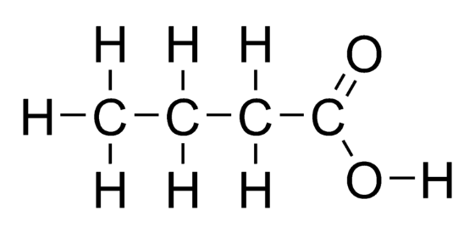
- 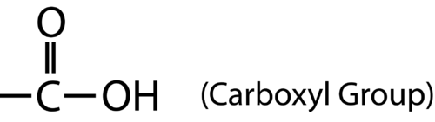 what organic molecules have them?
- 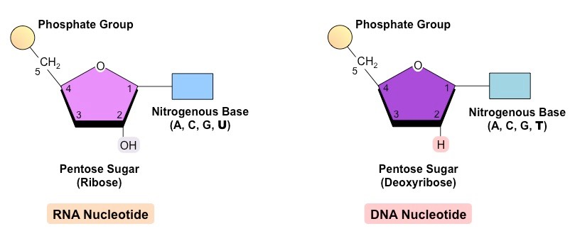

- 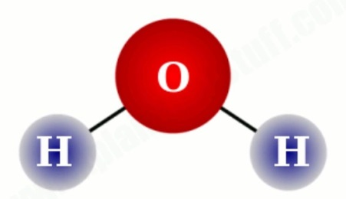

- What effects enzyme activity?

- Make a sketch of enzymes using substrate, catalyst, products and reactants.

- 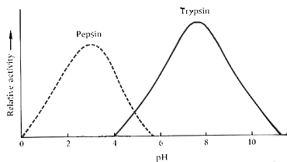

- Enzymes are examples of what organic compound group?
- Hydrolysis of maltose into 2 glucose molecules requires the addition of _____________.

- Glucose is converted to starch by the process of ….

- Where are lipids found in the cell?

6 How will you recognize glucose?
- What are catalysts that are proteins called?

- What happens to enzymes when they are boiled?

- What inorganic substance is necessary for all reactions to occur?

- What are the building blocks of proteins?

- Group of proteins that includes the building blocks of DNA and RNA?

- What element does protein always have in it?

- Throw in H2O and bust up a complex organic substance. What is this called?

- What are the building blocks of carbohydrates?

- What is a polysaccharide?

- What are the 2 enzyme models called?

- What process takes out H2O and makes more complex substances?

18 What are the four important polysaccharides?
- What do fats break down into?

25 What effects enzyme activity?

27
26 Make a sketch of enzymes using substrate, catalyst, products and reactants.

22 what organic molecules have them?
24 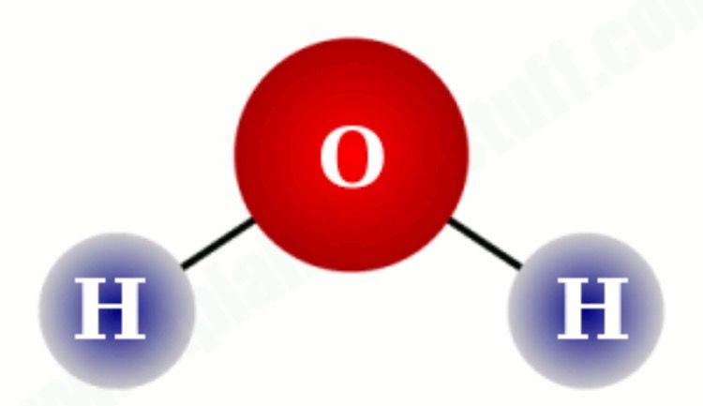
23
- A substance that speeds up a reaction is called a _________________________.

21 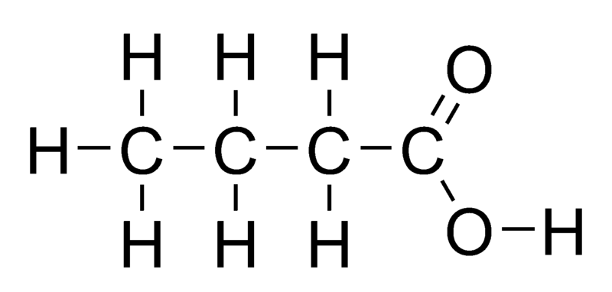
- An organic molecule has….

